**Santosh Rajak**

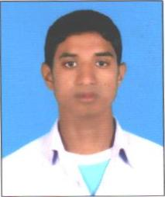Santosh Rajak is a student from Rajbiraj. He lives in small village, in a house made up of hays. The only source of income in his family is farming. His elder brother had to renounce his studies and started working to earn money so that they could pay back the loan which they took for their mother’s treatment. Affording food for five members in their family is also a dilemma. Santosh is a very remarkable student of his class. His school is seven kilometers from his home which he travels on an old cycle. His family also wants him to study but situations were never in their favor. When he heard of Sadbhaw Scholarship Program, he knew this can really help him to continue his studies. Fortunately he was also selected in the list of 40 students by the local committee. On the day of scholarship distribution, things went far too dramatic for him. His whole village was burnt to ashes which made him so depressed that he called us and said he won’t be able to collect scholarship because he can’t study anymore. But then he realized that if he completes his studies and become a well earning person, he can build his village again which can’t be scorched. So he showed up at the scholarship distribution ceremony.

Santosh Rajak wants to be a computer engineer and is now studying well in his school.